Bancroft Community Guide Complete

Megan Novak, Bancroft Village Clerk, received the Bancroft Community Guide Lite from Rick Nelson, NPPD’s Senior Economic Development Consultant, the first week of May.

Community Guides are published for NPPD communities served at retail or wholesale customers to use as a tool for recruiting new industry, commercial & retail businesses, and professionals. NPPD prepares the publication for printing and online with the assistance of city officials and others in the community. Included in each Community Guide Lite is a variety of detailed information on geography, economic development, labor, market access, infrastructure, communications, tax structure, local government, education, quality of life, community services, agriculture & raw materials, and climate.

Community Guides are included in the searchable database on NPPD’s website (sites.nppd.com). It can also be found on Cuming County Public Power District’s website at www.ccppd.com or directly at this link: https://s3.amazonaws.com/lois-files/59ed7fc5994c2e62b62c0cdb/hth3ZftO5.pdf

Thank you to Megan Novak for completing the information for the community guide and getting the pictures to NPPD to place in the book.

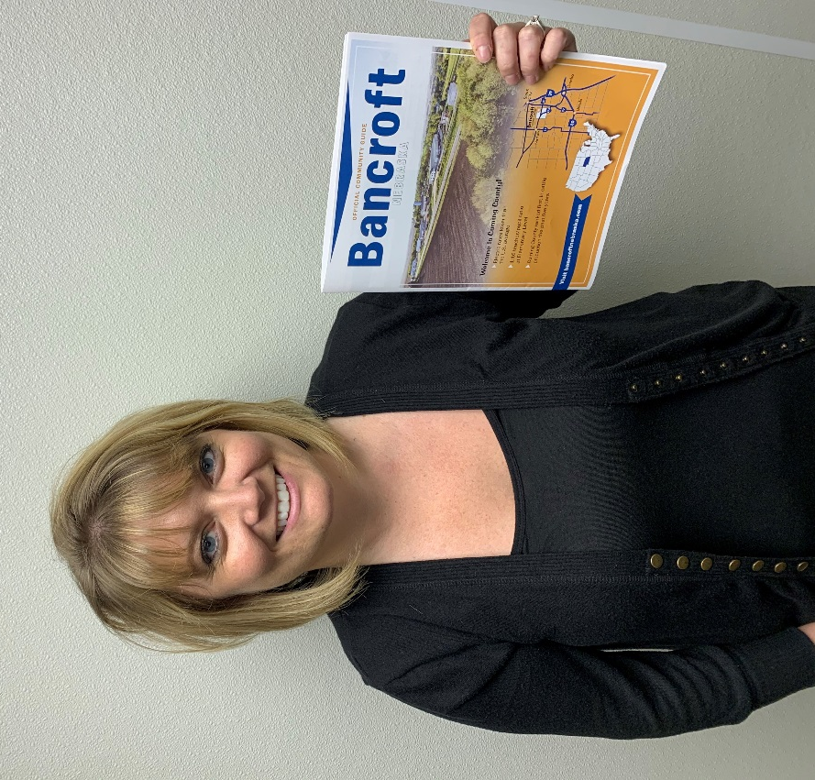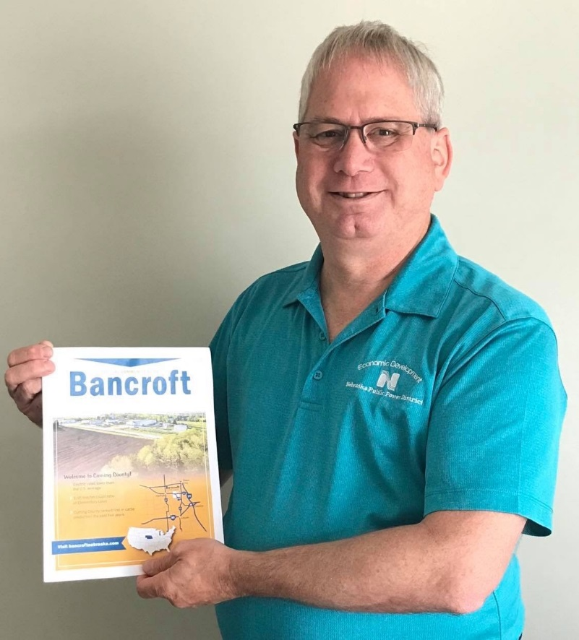
(Pictures: Megan Novak, Bancroft Village Clerk, received the Bancroft Community Guide from Rick Nelson, NPPD Senior Economic Development Consultant)

# # # # # # # # # # #

